**Name: Ayman Taha Ali**

**B.N: 238**

**Topic: Artificial Intelligence**

**GitHub Link: GitHub Pages (published Website):**

* **Artificial Intelligence Brief**

While exploiting the power of the computer systems, the curiosity of human, lead him to wonder, “Can a machine think and behave like humans do?” Thus, the development of AI started with the intention of creating similar intelligence in machines that we find and regard high in humans.

Artificial intelligence (AI) is truly a revolutionary feat of computer science, set to become a core component of all modern software over the coming years and decades. This presents a threat but also an opportunity. AI will be deployed to augment both defensive and offensive cyber operations. Additionally, new means of cyber-attack will be invented to take advantage of the particular weaknesses of AI technology. Finally, the importance of data will be amplified by AI’s appetite for large amounts of training data, redefining how we must think about data protection. Prudent governance at the global level will be essential to ensure that this era-defining technology will bring about broadly shared safety and prosperity.

* **Screenshots**

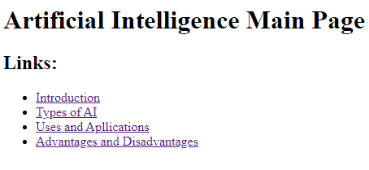

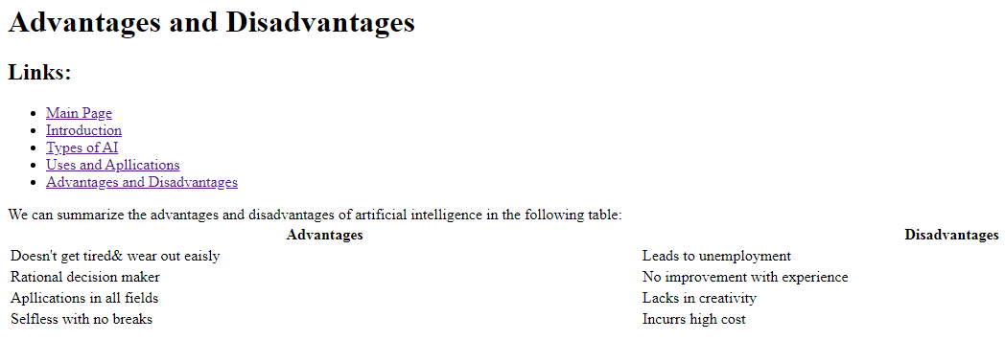

# Source Code

